**Experiment -13**

**By Aman Tyagi**

**Aim:** Prepare and Implement Docker Container Restart Policy.

1. Launching an instance using the following command

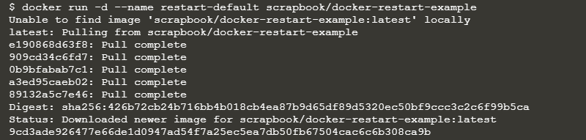

1. List all the containers

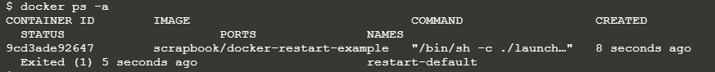

1. The logs will output a message.



1. Docker will restart the container three times before stopping.

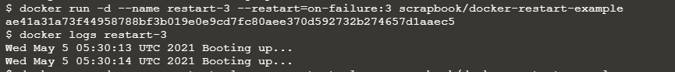

1. Using the always flag to automatically restart the container when it crashes.

